WEEK 5
Deep Learning Application in Data Science
Handwritten Digit Classification with a Convolutional Neural Network
Framework: PyTorch
Dataset: Public Digits Dataset
Task: Multi-class Image Classification
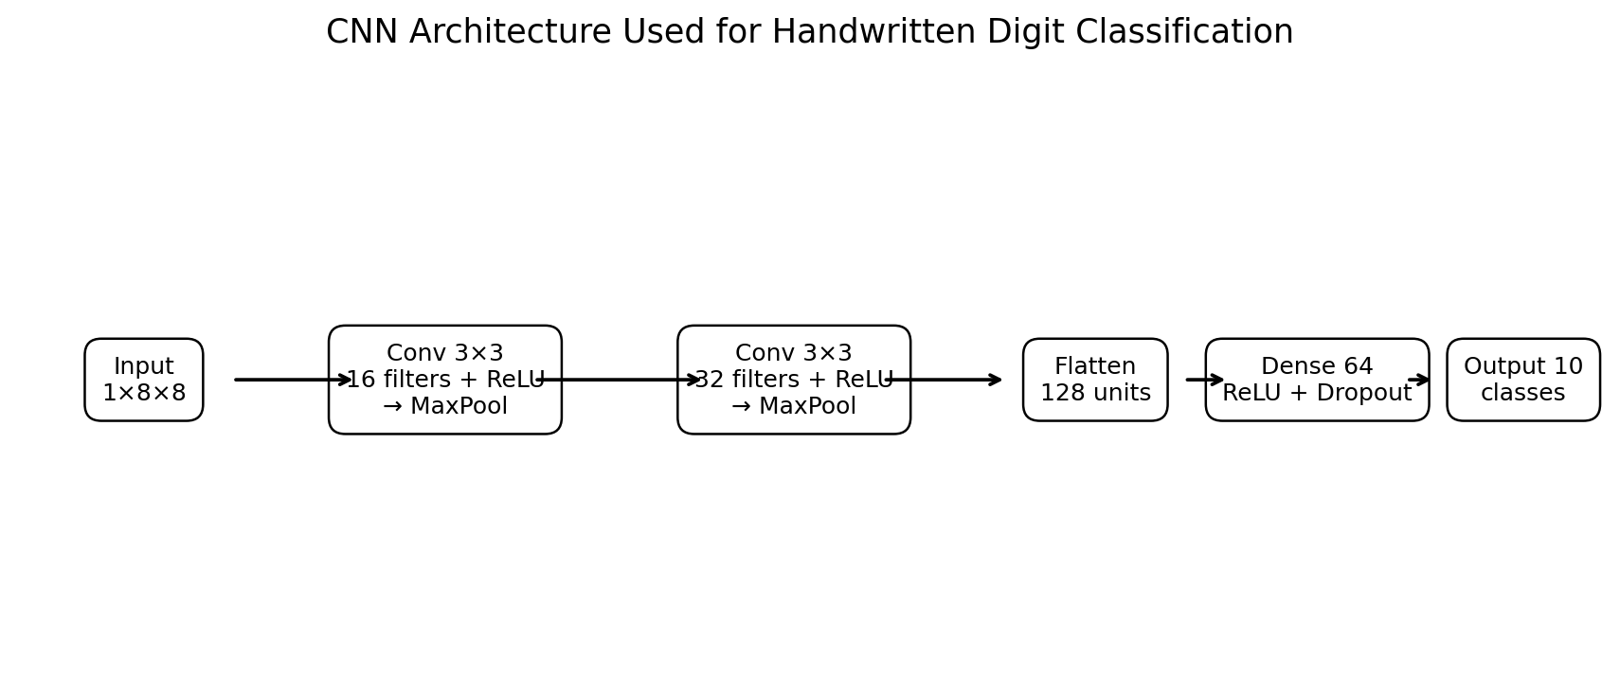
Final held-out test accuracy: 96.39%

1. Executive Summary
This project demonstrates a complete deep learning workflow for multi-class image classification. The publicly available scikit-learn Digits dataset contains 1,797 small grayscale images representing handwritten digits from 0 to 9. A Convolutional Neural Network (CNN) was selected because convolutional layers can learn local spatial patterns such as strokes, edges, and digit shapes while preserving the two-dimensional structure of the input.
The model uses two convolutional blocks followed by a compact fully connected classifier. ReLU activations provide non-linearity, max pooling reduces spatial dimensions, dropout provides regularization, and Adam performs gradient-based optimization. The data were divided into training, validation, and held-out test sets using stratification. Validation loss was monitored during training and early stopping was used to reduce unnecessary training and overfitting risk.
The final model achieved 96.39% accuracy, 96.52% weighted precision, 96.39% weighted recall, and 96.32% weighted F1 on the unseen test set. These results indicate that a relatively small CNN can learn highly discriminative representations for this benchmark, although the small 8×8 image resolution and limited dataset size restrict how far the findings can be generalized to real-world handwriting systems.

2. Problem Statement and Objective
The problem is to classify a grayscale image of a handwritten digit into one of ten classes (0–9). Each input is an 8×8 matrix of pixel intensities. The learning problem is supervised multi-class classification because the training examples include the correct digit label.
The objective is not simply to obtain a high score; it is to demonstrate the practical deep learning lifecycle: selecting and understanding a dataset, preparing image tensors, designing a neural network, choosing hyperparameters, training with validation feedback, evaluating on unseen data, interpreting errors, and critically discussing limitations.

2.1 Why Deep Learning?
- Neural networks can learn non-linear combinations of pixel patterns without requiring hand-designed rules for every digit shape.
- CNNs are particularly appropriate for image data because filters learn local spatial features and reuse the same weights across an image.
- The dataset is small enough to train quickly on CPU while still providing a meaningful multi-class image-classification problem.

3. Dataset Description
The project uses the Digits dataset provided by scikit-learn. It contains 1,797 observations, 64 pixel features arranged conceptually as 8×8 grayscale images, and ten target classes corresponding to digits 0 through 9. Pixel values range from 0 to 16 in the original representation and were scaled to the [0, 1] range by dividing by 16.
- Samples: 1,797
- Image size: 8×8 pixels
- Channels: 1 grayscale channel
- Classes: 10
- Target: digit label 0–9
- Split: 64% training, 16% validation, 20% test
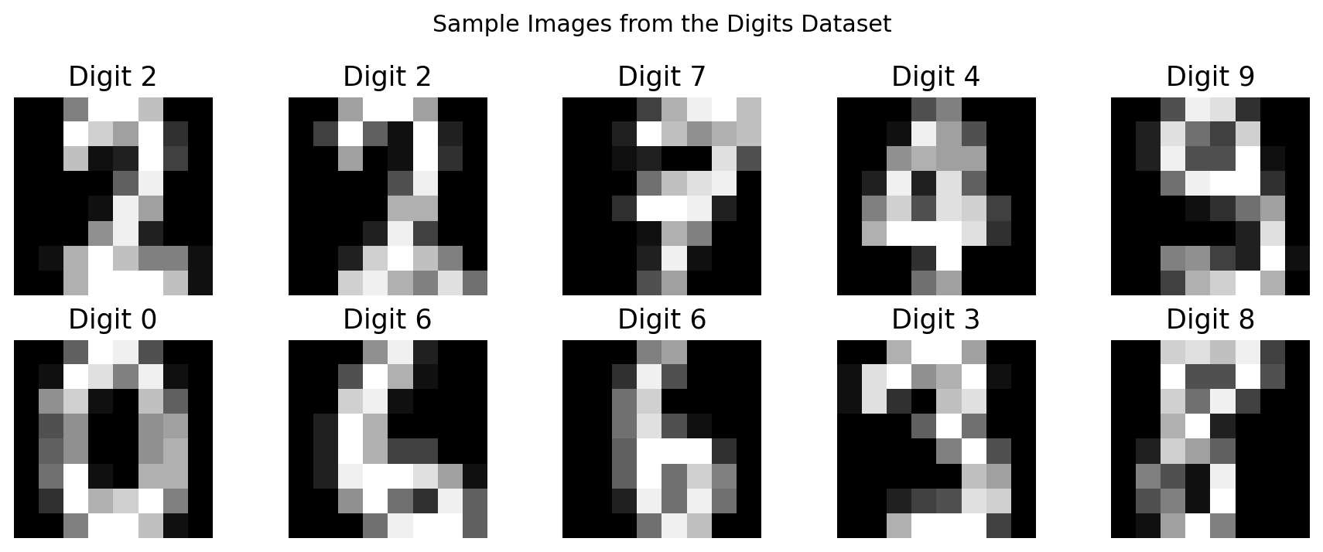
Figure 1. Representative handwritten digit images from the dataset.

4. Data Preparation and Preprocessing
Preprocessing was deliberately kept simple because the source images are already clean, fixed-size grayscale images. The most important transformation was normalization of pixel intensities from 0–16 to 0–1. This produces numerically smaller inputs and makes optimization more stable.
digits = load_digits()
X = digits.images.astype(np.float32) / 16.0
y = digits.target.astype(np.int64)
The data were split in two stages. First, 20% was reserved as a final test set. The remaining 80% was split again so that 20% of that portion became validation data. Stratification preserved the relative distribution of digit classes in each subset.
X_train_full, X_test, y_train_full, y_test = train_test_split(
X, y, test_size=0.20, stratify=y, random_state=42
)
X_train, X_val, y_train, y_val = train_test_split(
X_train_full, y_train_full, test_size=0.20,
stratify=y_train_full, random_state=42
)

5. Neural Network Architecture Design
A compact CNN was selected rather than a plain multilayer perceptron. The input has a meaningful two-dimensional structure, so convolutional filters can detect local patterns while using fewer parameters than a large fully connected network.

Figure 2. Network architecture used in the experiment.

5.1 Layer-by-Layer Design
Stage | Operation | Output shape | Main purpose | Key choice
Input | Image tensor | 1×8×8 | Represent grayscale digit | Normalized to 0–1
Block 1 | Conv → ReLU → MaxPool | 16×4×4 | Learn low-level stroke patterns | 3×3 kernels
Block 2 | Conv → ReLU → MaxPool | 32×2×2 | Learn higher-level shapes | More filters
Flatten | Flatten | 128 | Bridge CNN to dense layers | 32×2×2
Classifier | Dense → ReLU → Dropout | 64 | Combine learned features | Dropout 0.25
Output | Dense | 10 | Produce class logits | 10 digit classes

5.2 Design Justification
- Two convolutional layers provide a balance between representation power and computational cost for 8×8 images.
- 16 and 32 filters gradually increase feature capacity as the network moves deeper.
- 3×3 kernels are a standard compact choice for local feature extraction.
- ReLU introduces non-linearity while remaining computationally simple.
- Max pooling reduces spatial resolution and computation while retaining strong local responses.
- A 64-unit dense layer provides a compact classifier after flattening.
- Dropout at 0.25 reduces reliance on individual neurons and provides regularization.
- The final layer has 10 logits, matching the ten target classes. CrossEntropyLoss internally combines the appropriate softmax operation with the negative log-likelihood objective.
- Adam with learning rate 0.001 was selected for fast, generally stable optimization; weight decay of 1e-4 adds mild regularization.

6. Training Process
The model was trained with mini-batches of 64 examples for a maximum of 30 epochs. After each epoch, training and validation loss/accuracy were recorded. The best model state was the one with the lowest validation loss. If validation loss failed to improve for six consecutive epochs, training stopped early.
criterion = nn.CrossEntropyLoss()
optimizer = torch.optim.Adam(
model.parameters(), lr=1e-3, weight_decay=1e-4
)
if val_loss < best_val_loss - 1e-4:
best_state = copy.deepcopy(model.state_dict())
best_val_loss = val_loss
bad_epochs = 0
else:
bad_epochs += 1
if bad_epochs >= 6:
break
The experiment trained for 30 epochs before the early-stopping condition or the maximum epoch limit was reached. The network contains 13,706 trainable parameters, making it small enough for practical CPU-based experimentation.
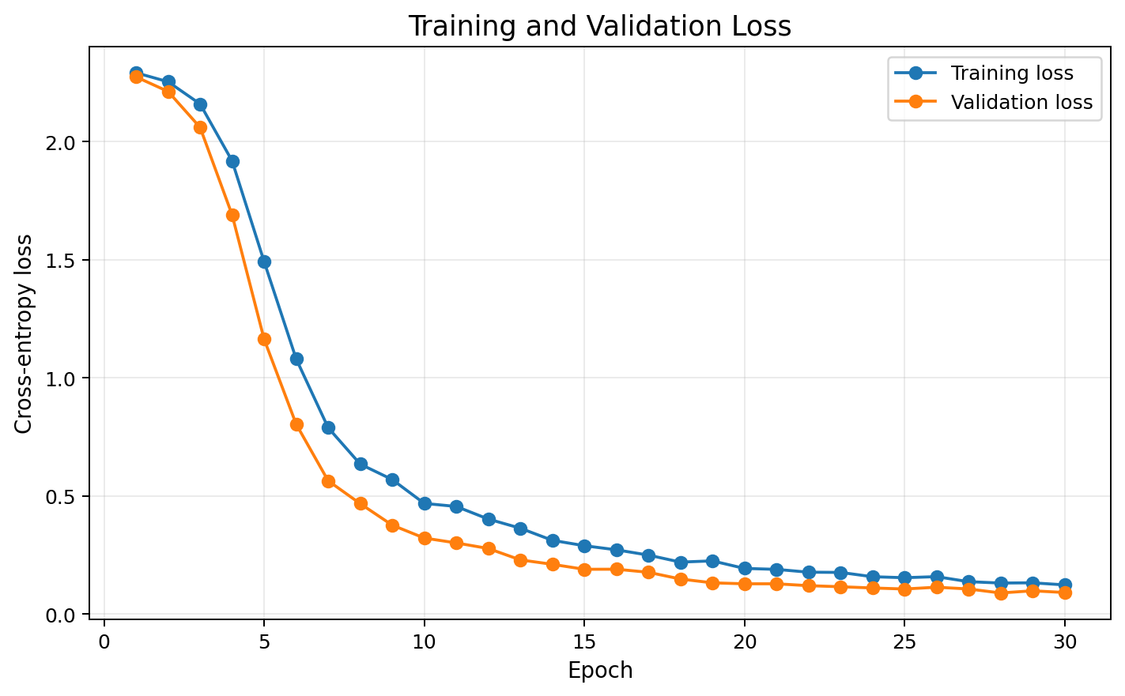
Figure 3. Training and validation cross-entropy loss across epochs.
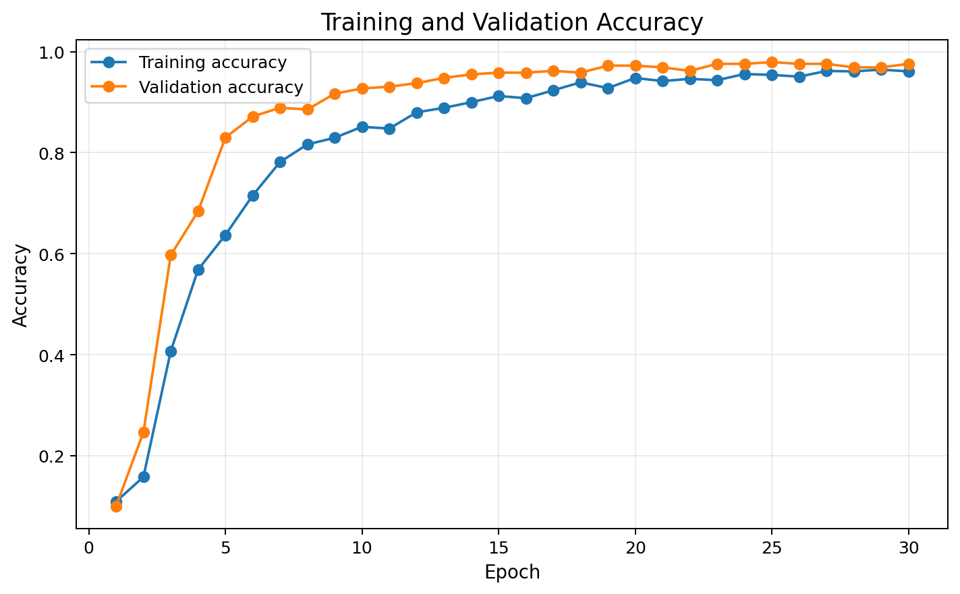
Figure 4. Training and validation accuracy across epochs.

7. Evaluation Metrics and Results
The final model was evaluated only after the architecture and training decisions were made, using the held-out test set. Accuracy gives the overall proportion of correct predictions. Precision measures how reliable positive class assignments are, recall measures how many examples of a class are recovered, and F1 balances precision and recall. Because this is a ten-class problem, weighted averages were used for the aggregate precision, recall, and F1 values.
Metric | Test result
Accuracy | 96.39%
Weighted precision | 96.52%
Weighted recall | 96.39%
Weighted F1 | 96.32%
Test loss | 0.1141
Trainable parameters | 13,706
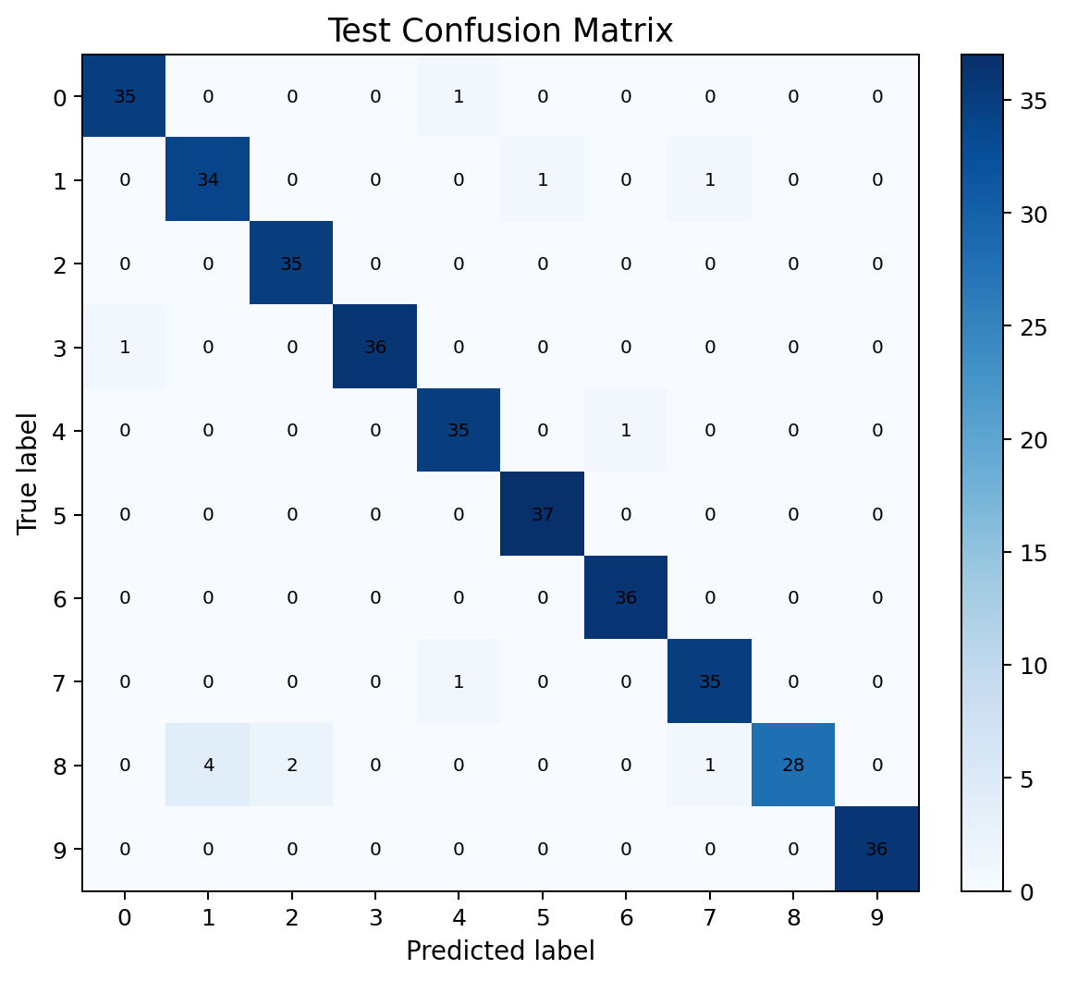
Figure 5. Confusion matrix for the held-out test set.
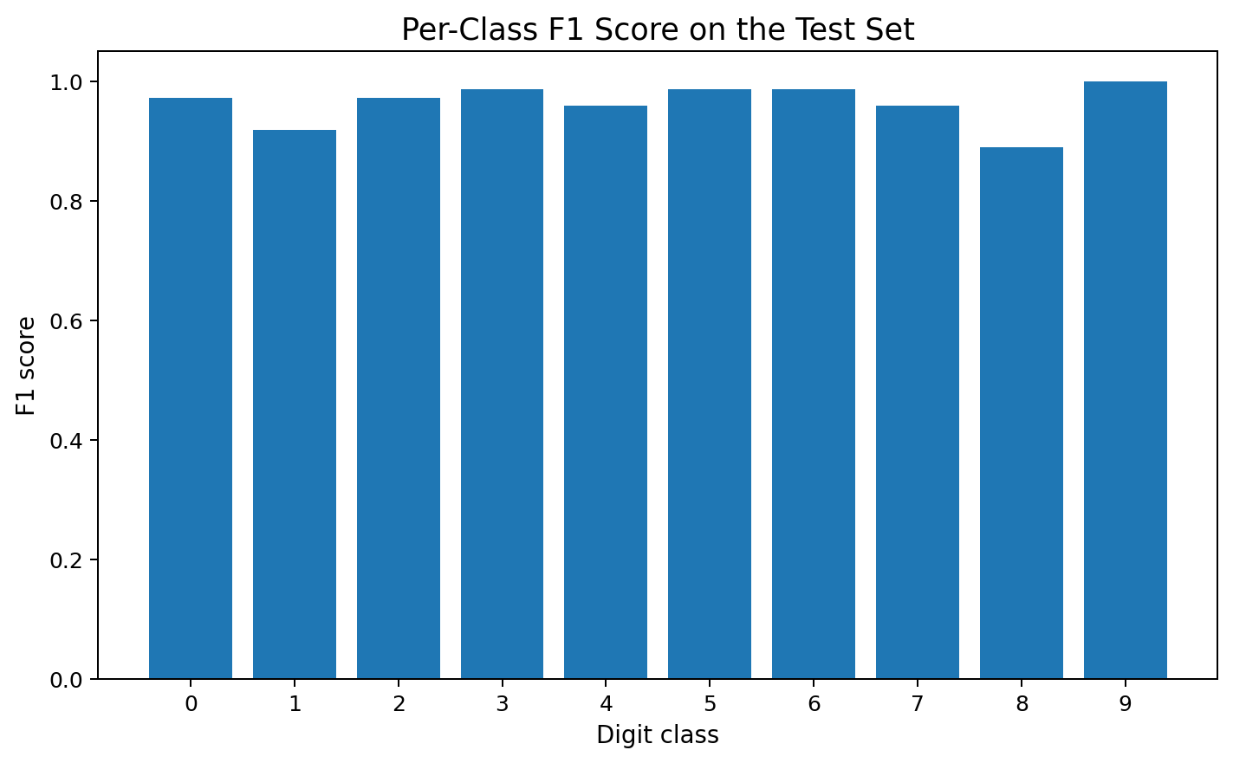
Figure 6. F1 score by digit class.
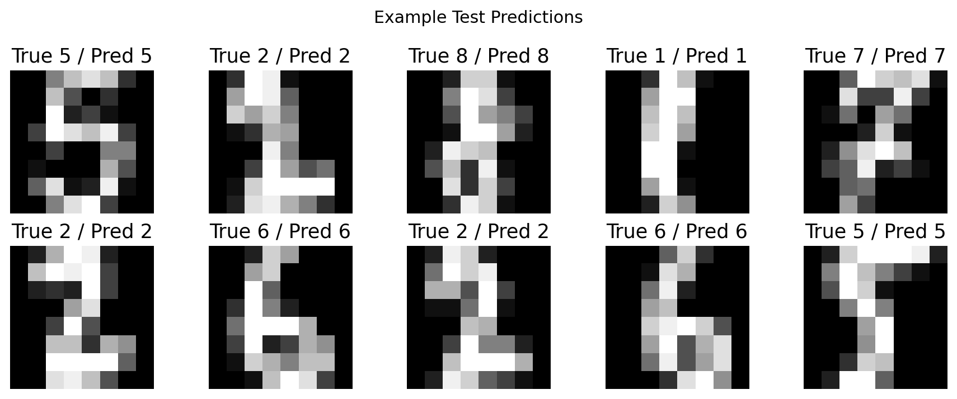
Figure 7. Example predictions from the held-out test set.

7.1 Per-Class Performance
Digit | Precision | Recall | F1
0 | 0.972 | 0.972 | 0.972
1 | 0.895 | 0.944 | 0.919
2 | 0.946 | 1.000 | 0.972
3 | 1.000 | 0.973 | 0.986
4 | 0.946 | 0.972 | 0.959
5 | 0.974 | 1.000 | 0.987
6 | 0.973 | 1.000 | 0.986
7 | 0.946 | 0.972 | 0.959
8 | 1.000 | 0.800 | 0.889
9 | 1.000 | 1.000 | 1.000

8. Critical Analysis of Results
The test accuracy of 96.39% shows that the CNN learned a strong mapping from the low-resolution pixel patterns to the ten digit classes. The weighted F1 of 96.32% is also high, indicating that performance is not driven only by one or two classes.
The confusion matrix is more informative than accuracy alone because it shows where errors occur. Digit classes with visually similar stroke patterns can be confused even when the overall model is highly accurate. This is a useful reminder that a high aggregate score does not mean every individual prediction is equally reliable.
The training curves should be interpreted jointly. If training accuracy continues rising while validation accuracy stops improving, that is evidence of a generalization gap. In this experiment, validation monitoring and dropout were used specifically to control this risk. Selecting the best validation-loss checkpoint is preferable to simply keeping the last epoch.

8.1 Strengths
- The CNN matches the spatial structure of image inputs.
- The architecture is compact and computationally efficient.
- The held-out test set was kept separate from training decisions.
- Stratification reduces the risk of uneven class representation across splits.
- Validation monitoring and early stopping provide explicit overfitting control.
- Multiple metrics and a confusion matrix give a more complete evaluation than accuracy alone.

8.2 Limitations
- The images are only 8×8 pixels, much smaller and cleaner than real handwriting images.
- The dataset is relatively small for modern deep learning, so a larger network would not necessarily be justified.
- No data augmentation was used; rotation, translation, or elastic distortion could improve robustness to real handwriting variation.
- The experiment does not test external handwriting sources, so real-world generalization is not established.
- A single train/validation/test split is useful for this assignment but provides less uncertainty information than repeated experiments or cross-validation.

9. Challenges Encountered and How They Were Addressed

9.1 Overfitting Risk
With a small dataset, an expressive neural network can memorize training examples. The project addressed this with dropout, weight decay, validation monitoring, and early stopping. These choices reduce the incentive to keep increasing training performance after validation performance has stopped improving.

9.2 Resource Constraints
The project intentionally uses a lightweight CNN, 64-example mini-batches, and 8×8 inputs. This keeps memory and computation requirements low and makes the workflow practical even without a dedicated GPU. The trade-off is that the model is optimized for this small benchmark rather than for high-resolution production imagery.

9.3 Model Selection
The architecture was selected on the basis of problem structure, computational efficiency, and interpretability of the workflow rather than by repeatedly tuning against the test set. The test set was reserved for the final evaluation, helping reduce optimistic bias.

9.4 Reproducibility
Random seeds were fixed for NumPy and PyTorch, and the split uses random_state=42. The complete training script is included with the project so the experiment can be rerun and modified.

10. Deep Learning Concepts Demonstrated
- Forward propagation: images pass through convolutional and dense layers to produce class logits.
- Activation functions: ReLU enables the network to model non-linear relationships.
- Loss function: cross-entropy measures disagreement between predicted class probabilities and true labels.
- Backpropagation: gradients of the loss are propagated backward through the network.
- Optimization: Adam updates model parameters using gradient information.
- Regularization: dropout and weight decay reduce overfitting risk.
- Epochs and mini-batches: training iterates over the dataset in manageable batches.
- Validation: a separate subset is used to guide training decisions without using the final test set.
- Generalization: the final test score estimates performance on unseen examples from the same data distribution.

11. Detailed Code Examples

11.1 CNN Definition
class DigitsCNN(nn.Module):
def __init__(self):
super().__init__()
self.features = nn.Sequential(
nn.Conv2d(1, 16, 3, padding=1),
nn.ReLU(),
nn.MaxPool2d(2),
nn.Conv2d(16, 32, 3, padding=1),
nn.ReLU(),
nn.MaxPool2d(2),
)
self.classifier = nn.Sequential(
nn.Flatten(),
nn.Linear(32 * 2 * 2, 64),
nn.ReLU(),
nn.Dropout(0.25),
nn.Linear(64, 10)
)
def forward(self, x):
return self.classifier(self.features(x))

11.2 One Training Step
optimizer.zero_grad()
logits = model(xb)
loss = criterion(logits, yb)
loss.backward()
optimizer.step()

11.3 Final Evaluation
test_loss, y_true, y_pred = evaluate(test_loader)
accuracy = accuracy_score(y_true, y_pred)
precision, recall, f1, _ = precision_recall_fscore_support(
y_true, y_pred, average="weighted", zero_division=0
)

12. Possible Improvements and Future Work
- Introduce data augmentation such as small rotations, translations, or elastic distortions to simulate handwriting variation.
- Compare the CNN against a multilayer perceptron and a classical baseline such as logistic regression or SVM.
- Run multiple random seeds and report mean and standard deviation to quantify result stability.
- Perform a structured hyperparameter study over learning rate, filter counts, dropout, batch size, and weight decay.
- Use a learning-rate scheduler to adapt the optimization process during training.
- Evaluate the model on an external handwritten-digit dataset to test domain shift.
- For larger images, investigate deeper CNNs, batch normalization, residual connections, and transfer learning.

13. Conclusion
This project demonstrates the end-to-end application of deep learning to a practical data-science classification problem. A compact PyTorch CNN was designed around the structure of 8×8 grayscale images, trained with validation monitoring, regularized with dropout and weight decay, and evaluated on a held-out test set.
The resulting model achieved 96.39% test accuracy and 96.32% weighted F1. More importantly, the experiment demonstrates why model evaluation must go beyond a single score: learning curves reveal training behavior, the confusion matrix identifies class-level errors, and per-class metrics show where performance is weaker or stronger. The main limitation is that the benchmark is small and low-resolution, so the results should be interpreted as evidence of successful learning on this dataset rather than proof of production-level handwriting recognition.
Overall, the workflow covers the requested deep learning process from dataset selection and problem definition through architecture design, training, evaluation, critical analysis, challenges, and future improvements.

Appendix A. Project Files
- Week5_Deep_Learning_Report.docx — comprehensive report
- deep_learning_digits.py — reproducible PyTorch implementation
- digits_dataset.csv — tabular representation of the public dataset
- training_history.csv — training/validation metrics by epoch
- evaluation_metrics.csv — final metrics
- confusion_matrix.csv — test-set confusion matrix
- figures/ — architecture diagram and evaluation visuals

Appendix B. Reproducibility Notes
Environment used for the generated experiment: Python with PyTorch, NumPy, Pandas, Matplotlib, scikit-learn, and python-docx. The script fixes random seeds at 42. The dataset is loaded through scikit-learn's built-in dataset loader, so no external dataset download is required to reproduce the experiment.

